**WEEK 2: Assignment**

1. Following are the slides number which has questions that you need to address.

i)Lecture 1: Slide no. 15

Q.1 How many number of Edges and vertices are there in the following graph?

Answer: The graph 1 has 5 vertices and 4 edges.

V={a,b,c,d,e}

E={{ab},{ac},{bd},{dc}}

Q.2 How many number of pendent/leaf vertex/vertices are there in the following graph?

Answer: The number of pendent/ leaf vertex/vertices in graph 1 is 0; defined as pendent vertex /leaf vertex which has its has degree 1.

Q.3 How many Isolated vertex/ vertices are there in the following graph ?

Answer: It is defined as vertex with degree zero . So ‘e’ is isolated vertex in graph 1.

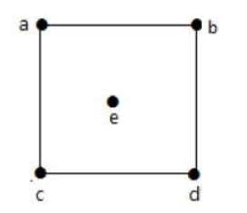

Graph: 1

Q.4 How many number of Edges and vertices are there in the following graph?

Answer: The graph 2 has 6 vertices and 5 edges.

V={a,b,c,d,e,f}

E={{ab},{ac},{bd},{dc},{cf}}

Q.5 How many number of pendent/leaf vertex/vertices are there in the following graph?

Answer: The number of pendent/ leaf vertex/vertices in graph 2 is 1 .i.e. ‘f’; defined as pendent vertex /leaf vertex which has its has degree 1.

Q. 6How many Isolated vertex/ vertices are there in the following graph ?

Answer: It is defined as vertex with degree zero . So ‘e’ is isolated vertex in graph 2.

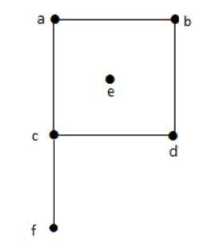

Graph:2

ii)Lecture 3: Slide no. 11

Q.1 Identify which of the two images has Connected and Disconnected Graph

Answer: Graph ‘G’ is connected graph and graph ‘H’ is disconnected graph .

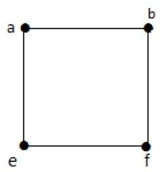

Graph ‘G’

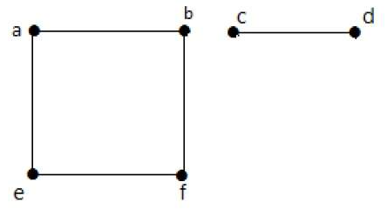 Graph ‘H’

iii)Lecture 3: Slide no. 27

Q1.Create a Table that denotes the weight of all the nodes to each other:

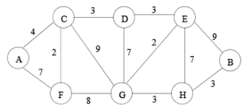

Answer:

|  |  |  |  |  |  |  |  |  |
| --- | --- | --- | --- | --- | --- | --- | --- | --- |
|  | A | B | C | D | E | F | G | H |
| A | 0 | 0 | 4 | 0 | 0 | 7 | 0 | 0 |
| B | 0 | 0 | 0 | 0 | 9 | 0 | 0 | 3 |
| C | 4 | 0 | 0 | 3 | 0 | 2 | 9 | 0 |
| D | 0 | 0 | 3 | 0 | 3 | 0 | 7 | 0 |
| E | 0 | 9 | 0 | 3 | 0 | 0 | 2 | 7 |
| F | 7 | 0 | 2 | 0 | 0 | 0 | 8 | 0 |
| G | 0 | 0 | 9 | 7 | 2 | 8 | 0 | 3 |
| H | 0 | 3 | 0 | 0 | 7 | 0 | 3 | 0 |

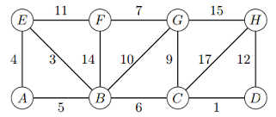

Answer:

|  |  |  |  |  |  |  |  |  |
| --- | --- | --- | --- | --- | --- | --- | --- | --- |
|  | A | B | C | D | E | F | G | H |
| A | 0 | 5 | 0 | 0 | 4 | 0 | 0 | 0 |
| B | 5 | 0 | 6 | 0 | 3 | 14 | 10 | 0 |
| C | 0 | 6 | 0 | 1 | 0 | 0 | 9 | 17 |
| D | 0 | 0 | 1 | 0 | 0 | 0 | 0 | 12 |
| E | 4 | 3 | 0 | 0 | 0 | 11 | 0 | 0 |
| F | 0 | 14 | 0 | 0 | 11 | 0 | 7 | 0 |
| G | 0 | 10 | 9 | 0 | 0 | 7 | 0 | 15 |
| H | 0 | 0 | 17 | 12 | 0 | 0 | 15 | 0 |

iv)Lecture 4: Slide no. 09

Q.1 Find the Hamiltonian Path and Cycle for the above graph (G). List all the possible Hamiltonian paths and cycles.

Answer: Starting from m-h-c-e-g-j-l-i-k-f-d-a-b so ending at b it makes a Hamiltonian path where each is visited once. No Hamiltonian cycle as m and b are not joined to each other.

Starting from a-b-c-e-h-j-m-e-k-i-g-d-f so ending at f there is a Hamiltonian cycle as a and f are connected.

Starting from k-l-m-j-h-e-c-b-d-g-i-f-a so ending at a there is no Hamiltonian cycle .

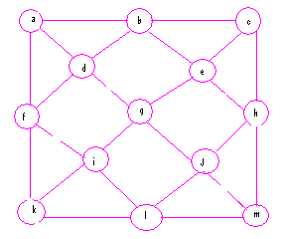

Graph ‘G’

2.Make the following graph a disconnected graph and justify your changes.

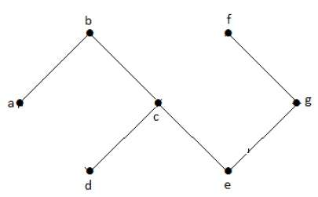

Answer: When the graph does not contain at least two connected vertices or when the two components are independent and not connected to each other then it is called disconnected graph as shown below.

f

fjo

f

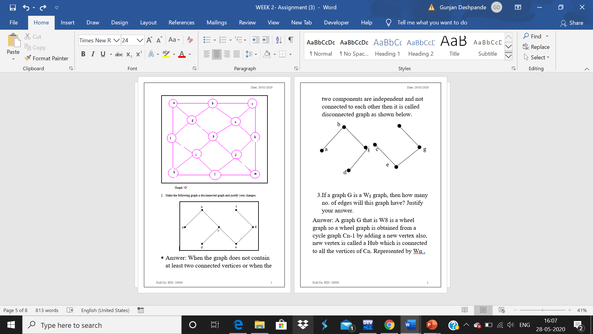

3.If a graph G is a W8 graph, then how many no. of edges will this graph have? Justify your answer.

Answer: A graph G that is W8 is a wheel graph so a wheel graph is obtained from a cycle graph Cn-1 by adding a new vertex also, new vertex is called a Hub which is connected to all the vertices of Cn. Represented by Wn .

Formula: No. of edges from hub to all others vertices + No. of edges in all other nodes in cycle graph without a hub

i.e.

E=(n-1)+(n-1)

E=2(n-1)

Number of edges will be in a wheel graph :

E =2(n-1)

E=2(8-1)

E=2(7)

Edges=14.

4.If a graph has 10 vertices then how many no. of simple graph can be generated from the it? What is the maximum no. of edges this graph will have? Justify your answer.

Answer: So for a simple graph the number of simple graphs possible with

‘10’ vertices = 2nc2 = 2n(n-1)/2

= 2^10(10-1)/2

=2^45

Maximum number of edges will be n(n-1)/2

Where the n is 10. So:

E=n(n-1)/2

E=10(10-1)/2

E=10(9)/2

E=45.

5.If a graph is a K5,7 then draw the graph such that it is a complete graph. How many no. of edges will this graph possess? Justify your answer.

Answer: The number of edges in the graph will be m*n that is 5*7 =35 edges.